# What is this game

This game of progression has been inspired by the current political events occurring in several different countries. A game of progression is when the players must perform a predefined set of actions to complete the game as Tulleken explains (Tulleken 2015).

Research was carried out into all the different factors of elections and how the candidates gain their influence from the people and what party they’re representing, previous votes, voters background and previous performances as Dugger explains (Dugger 2015). The game is based on the voting/popularity system.

The mechanics chosen are a levels system, lock and key system, turn moving and dice throwing. The level system mechanic uses the votes represented with the counters on each section of the board. The game will also use a Lock and Key system by using a boundary on the board and players need to get a certain number of votes to pass. It will also use a dice throwing mechanic for the players encounter system.

# Running for President/ Square One

It is nearly the end of the presidential elections and the existing president is not able to stand for re-election. The two leading candidates have been discovered, however the gap between them is too small for anyone to be sure who will win the final vote. They need to go back on the campaign trail and persuade more people to vote for them.

The objective of the game is for the players to navigate their way through the game board collecting votes along the way until they have enough to become president, this can either be a straight race or they can use positioning tactics to block their opponents moves or force them onto squares where the votes have already been collected.

The players can name their characters to reflect current elections, for example Hilary Clinton & Donald Trump (USA), or François Fillon and Marine Le Pen (France) as Charles explains (Devellennes 2016), or perhaps people they know who are standing for a student union election.

At the end of the game if the players wish to play again using the same charters but with the previous winner as the incumbent, they can give one player an advantage depending on whether the incumbent had been a good president or not.

# First Ruleset

1. For 2 players.
2. Players start at the bottom of the game world.
3. Players roll a six sided die, rolling 1-2 allows one move, 3-4 is two moves and 5-6 is three.
4. The players move between intersections and not inside the squares.
5. At each intersection there is a counter representing one vote.
6. When a player lands on a counter they remove it from the game board
7. The players have to collect a minimum number of points to get past the Yellow, Blue and Orange gate boundaries. The yellow gate requires eight votes, blue is 20 and orange is 40.
8. All collectable counters are colour coded to their section on the game board.
9. All gate boundaries are one way only and players cannot turn back to collect votes from the previous section of the board.
10. If a player lands on the other, they each have to roll a die once, whoever has the largest score takes two votes from the other player’s collected votes
11. No player can have a negative number of votes.
12. The winner is the first player with 40 votes to reach the top of the game board.

# Game world

The game board shown in figure 1 is a 12x11 board

The players start at the bottom on any unoccupied intersection shown with the black starting points.

The yellow, blue and orange lines represent one of the core mechanics called regional gating (Hauteville 2011) or a lock and key system (Adams & Dormans 2012 pp247-250).

The player needs to collect enough votes to pass the coloured boundary lines and gain access to the next section.

Figure 1

# Game contents

1. One game board sized 31cm x 29.7cm
2. 30 yellow counters ( 22 for game board, 8 spare ) (figure 2)
3. 30 blue counters ( 22 for the game board, 8 spare )(figure 3)
4. 40 orange counters ( 33 for game board, 7 spare )(figure 4)
5. 6 coloured player pieces ( two to be used each game)(figure 5)
6. 1 six sided die (figure 6)



Figure 4

Figure 3

Figure 2

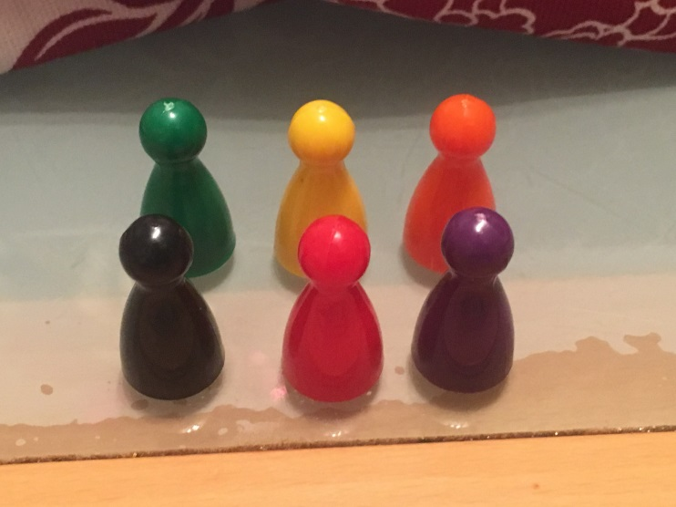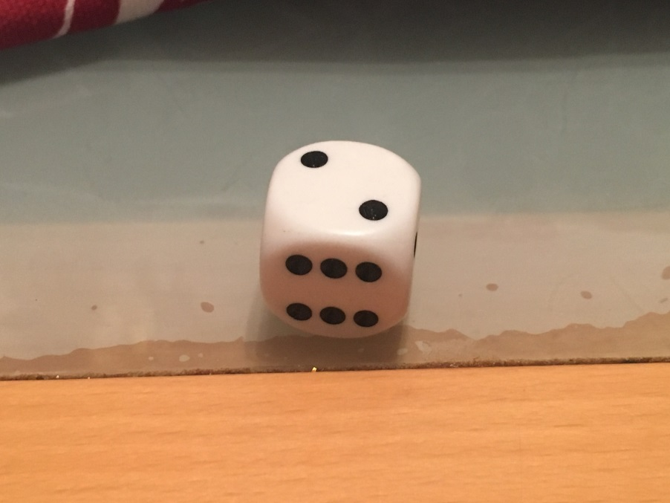

Figure 6

Figure 5

# Game Mechanics, Play Tests & Iterations

After constructing the game, I asked some friends, fellow students and family members to play it whist I made notes. Afterwards I took further suggestions from the players on how to improve the game.

I observed that when a player got lucky with their dice roll and their opponent didn’t, the game quickly became one sided, causing dissatisfaction for one player and not long after quitting the game, this occurred because this game mechanic relies of chance rather than strategy.

So my first iteration is to remove the dice rolling mechanic and replace it with a choice of two move profiles, which the players select before the game commences.

* Profile 1: move up/down 1 or 2 spaces or 1 space left/right
* 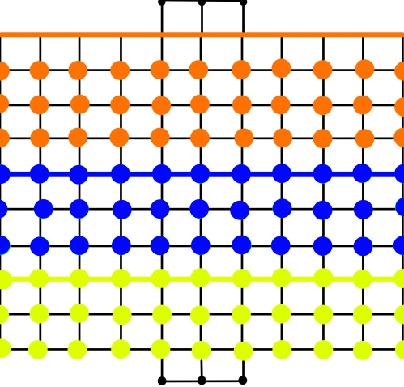Profile 2: move up/down 1 spaces or 1 or 2 space left/right

This new rule allowed both players to think about move strategy, before the game starts and throughout the game and removed the chance element, (Adams 2010 p325).

With this new rule in place it frequently occurred that a player could move but could not collect any votes as they were landing on the boundary between two zones.

So, my next iteration is to add one whole row of colour coded counters to the yellow and blue boundaries, as shown in figure seven.

This iteration allowed the players to use their chosen move profile more effectively, but did require 11 more yellow and blue counters to be added to the game contents.

Figure 7

During further play-test with this iteration, players commented, that with all counters having the same value, they had to collect a considerable number to complete the game, therefore the one vote per counter system wasn’t working as an effective vote collecting system

I therefore changed the values for the blue counters to two votes and orange to three votes, whilst leaving yellow at one, this iterated then made it too easy to get past the lock and key boundaries and was ineffective towards gameplay.

So, I increased the values of the blue boundary to 30 and orange boundary to 70, so they were then high enough to challenge the players as Hauteville recommends (Hauteville 2011).

With this iteration, I noticed that the players didn’t need to encounter each other because there where more than enough counters for both players to collect on the game board, which had turned the game into a race to the top of the board without the need to interact with each other which negated this part of the game play. So, I further increased the boundaries to 20 votes for yellow, 60 votes for blue and 110 votes for orange as Adams recommends to balance out the game. (Adams & Dormans 2012 pp247-250), this resulted in the players having to interact with each other a lot more often to progress through the levels.

However, this often resulted in stalemate situation as the encounter rewards wasn’t good enough to get past the set boundaries, and since both players could easily lose at the next encounter, so I iterated the player encounter rule by changing the winning rewards to two votes for the yellow section, four votes for the blue and six for the orange as Shell explains to help balance the games. (Shell 2008 p177). The winning player then drains these votes from the losing player’s total votes (Adams & Dormans 2012 pp62-63). With this iteration, the players were encouraged to attack each other for more votes, but as play-test went further, more problems were encountered.

When one of the players passed through a boundary, the opponent was often left with not enough collectable votes to follow them, so was then not able to progress (Adams & Dormans 2012 p69) resulting in the positive feedback to be better controlled (Adams 2010 pp350-351).

To stop this from happening I introduced a grinding mechanic to the game as Adams explains (Adams 2010 p325).

1. After two moves are made by both players all the counters previously collected are replenished and are doubled in value.

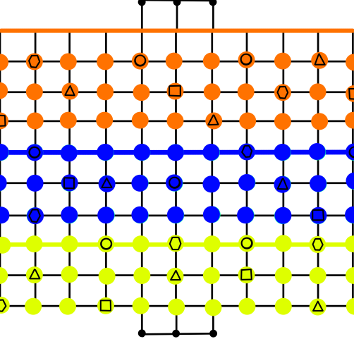

This made it easier for the loosing player to collect the votes needed to pass through to the next section and catch up with their opponent; however, this required even more yellow and blue counters to be added to the game contents, in both cases 66 for the game board and 14 spare.

After adding this new grinding mechanic, the players started to get discouraged because they were just collecting counters so I decided to add positive and negative move variables to some of the counters. These counters are placed face down on the board and out of view. Once the counters are found and put into effect the counter is removed from the board and added to the player’s total votes. There are three counters of each variable for each section of the board. Players can place these bonus counters wherever they like as long as there colour code remains the game. This gave this rule an element of chance as well as strategy before the game starts.

Figure 8

The variables are listed below and an example is shown on Figure eight

1. An extra move up/down (Triangle)
2. An extra move left right (Square)
3. Minus a move left/right (Circle)
4. Minus a move up/down (Hexagon)

Note: - a player can only add variables to a maximum of three and only be negated to one in any direction. These counters are not replaced through the grinding mechanic and can only be used once. With this final iteration included there was more tension between the players as they used strategy to get the bonuses.

Once I added the previous new mechanic to the game I realised that the orange section didn’t require any counters for the grinding mechanic because whichever player gets past the orange boundary is the winner so I therefore reduced the orange counters to 33 for the game board and seven spare.

The game then flowed well and soon there was a winner, after which they wanted to play again, so I added a simple throw of the dice to decide if the winner had been a good president and start the game with a six vote lead, if they lose they had a bad presidency and the other player starts with a six vote lead.

**Word count: 1634**

# Bibliography

Hauteville, C. (2011). *Gating.* Available: <https://goo.gl/cxO1oq>. (Last accessed 3rd Jan 2017 ).

Adams, E & Dormans, J. (2012). Common Mechanisms. In: Johnson, J & Wimpsett, T *Game Mechanics Advanced Game Design*. United States: New Riders. p140-142.

Adams, E & Dormans, J. (2012).Progression Mechanisms. In: Johnson, J & Wimpsett, T *Game Mechanics Advanced Game Design*. United States: New Riders. p247-257.

Adams, E. (2010). Game Balancing. In: Adams, E *Fundamentals of Games Design*. 2nd ed. United States: New Riders. p324-326.

Schell, J. (2008). Game Mechanics Must be in Balance. In: Morgan Kaufmann *The Art of Games Design*. Burlinton: Elsevier. p171-180.

Adams, E. (2010). Game Balancing. In: Adams, E *Fundamentals of Games Design*. 2nd ed. United States: New Riders. p349-351.

Devellennes, C. (2016). *French election 2017 meet the candidates.* Available: <https://goo.gl/w0vKVj>. Last accessed 16th Jan 2017.

Tulleken, H. (2015). *Color in games: An in-depth look at one of game design's most useful tools.* Available: <https://goo.gl/F1qz78>. Last accessed 10th March 2017.

Dugger, A. (2015). *Factors that Influence Voters During Presidential Elections.* Available: https://goo.gl/6O2bCe. Last accessed 10th March 2017.